Exp.No:26
26. Insert water marking to the image using OpenCV.

Aim:
To insert a text watermark on an image using OpenCV.
Procedure:
- Read the input image Tower.jpg.
- Define the watermark text.
- Select the font, position, size, and thickness.
- Add the watermark using cv2.putText().
- Resize the image for a smaller display.
- Display the watermarked image.
- Save the output image.
Program:
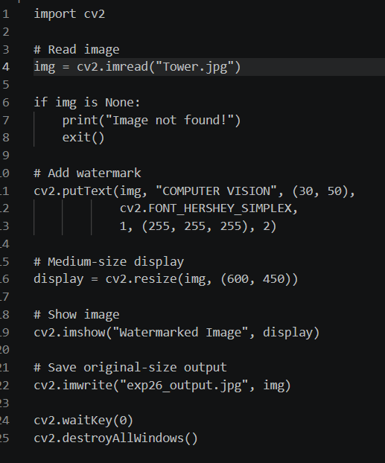
Input:

Output:

Result:
The watermark was successfully inserted into the image using OpenCV, and the watermarked image was saved successfully.

